IKEA Four Multi Coloured Dining Set

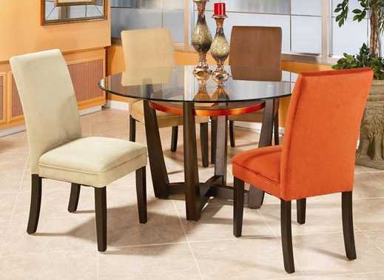

|  |
| --- |
| **DESCRIPTION** |
| IKEA introduces stylish four seated dining set with a rich wooden finish. The set of tables and chairs is perfect to create the perfect artistic look which means the multi colored chairs which is filled with air packed form and does not lose its durability. The chemical glass which is kept at the top of cross legged table is very strong and does not break easily. The cross pattern helps to maintain and share gravity which makes the table very stable. |

|  |  |  |
| --- | --- | --- |
| **Price** | **1200$** | |
| **Dimensions** | **Table H** x **W** x **L** | **35in x 33in x 33in** |
| **Chairs H** x **W** x **L** | **25in x 16in x 20.5in** |
| **Features** | **Four Chairs and One Table with chemical glass on top helps to maintain reflected heat so that the temperature and expansion of wood is constant it does not form cracks.** | |
| **Finished** | **Brown enlisted Polished** | |
| **Available in** | **Brown and Black** | |